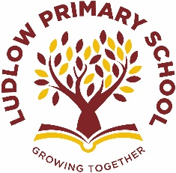

New children's books we love

September

## **Every month, BookTrust review dozens of new books for children and teenagers. Here are the ones they liked best in Semptember: guaranteed to get your child reading...**

**These are just a few of their suggestions. For the full list have a look at their website**

[**https://www.booktrust.org.uk/books-and-reading/our-recommendations/best-new-books/**](https://www.booktrust.org.uk/books-and-reading/our-recommendations/best-new-books/)

## **For ages 0-3 and up**

**For ages 4-5 and up**

## **For ages 6-8 and up**

**

## **For ages 9-11 and up**



