ABDULMAJID'S STORY

Syria
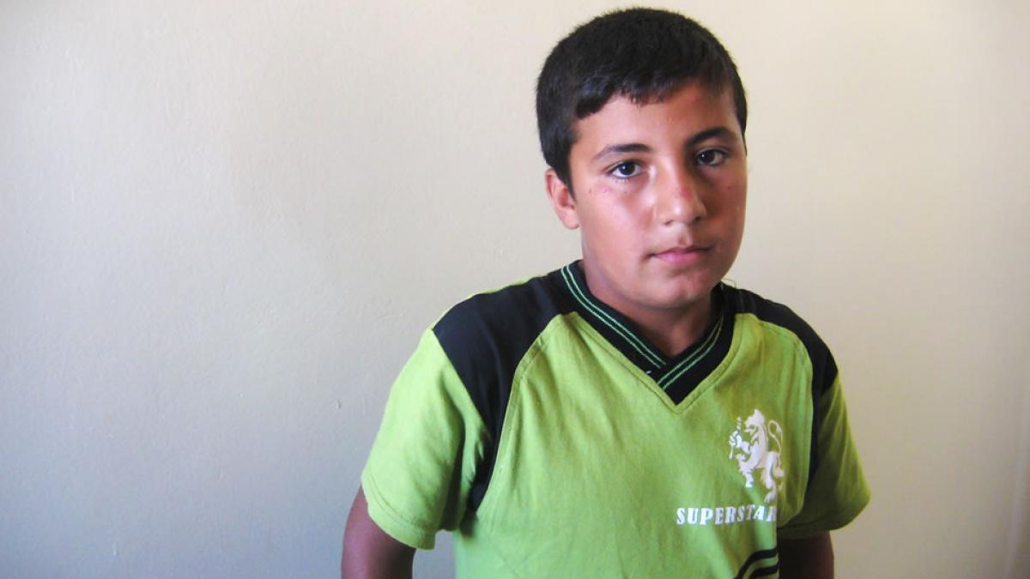Abdulmajid's name has been altered to protect his identity.

THE NIGHT BEFORE WE FLED, A PLANE ATTACKED OUR NEIGHBORHOOD. IT WAS VERY DARK. WE WERE ALL HIDING. THE NOISE WAS VERY LOUD SO I STAYED AWAKE. WE ALL STAYED FLAT ON THE FLOOR FOR HOURS.

The next morning Abdulmajid’s parents and their 10 children fled their family home. His school was destroyed on the same day.

“We didn’t take anything. There was no time. On the road I saw houses in rubble and burned out cars. I saw massacres, people and children, killed without any reason.”
He pauses, thinks and then whispers:
“On the road I also saw a small body of a dead baby without a head. When we passed that, I had to close my eyes.”

NIGHTMARES OF WAR
Once he arrived in Lebanon, his father built a tent from wood and plastic.
“Things are good here.... In Syria I was awake every night for at least two months because of all the scary sounds. I was always afraid we would be killed. Here I sleep better but I do have nightmares.”
He explains he has the same nightmare almost every night: “I am in a car with beheaded people and I am the only one that is still alive.”
He stops and can’t continue. “When I wake up crying my mum comes to comfort me.”
At home Abdulmajid never talks about what he saw.
“We try to forget about it; it is our secret.”

PSYCHO-SOCIAL SUPPORT

He’s attending school in Lebanon now and participates in War Child’s psycho-social sessions three times a week.

They combine creative activities with games and group discussions to build the resilience and improve the coping skills of children who've experienced trauma.
“I really try to forget; we play and laugh and have fun. I made a lot of new friends, and by having fun I can forget.”
He loves drawing: “Always when I draw, I draw a happy family. After school I give it to my mum and it makes her very happy.”

THE FUTURE OF SYRIA

“I miss my house, my school and my nice clothes. And of course I miss my best friend Basel.
"I understand that we are here because it is safer but I miss my country, that’s where I belong and I hope to go back very soon.
"When I grow up I want to help to rebuild Syria. I am sure there will be a lot of work for me to do there.”

