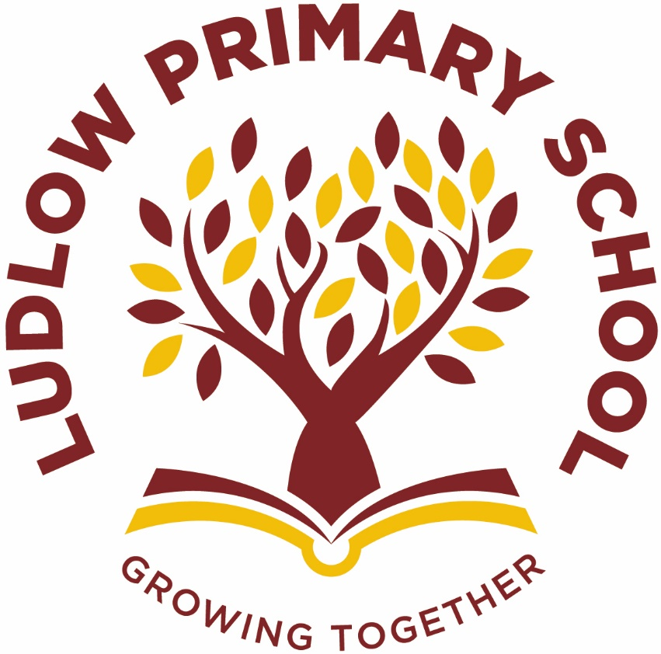

Geography at Ludlow Primary School

Our Curriculum Drivers at Ludlow Primary School
Social Skills and Language | Global Identity | Aspirations, resilience and growth mindset | Physical and mental health and well-being
Our Core Values
Independence | Happiness | Honesty | Kindness

When Ludlow Primary School was created in 2019 from the amalgamation of Ludlow Infant and Ludlow Junior School, we had the exciting opportunity to consider our school community’s needs and create a curriculum specifically tailored for them.

We have devised four drivers that run through our school curriculum. They are tailored to our pupil’s specific needs and take account of the opportunities and challenges in the context of our school community and our pupils’ lives.

These join with our core values to help children understand and appreciate the world around them so they can develop into responsible, knowledgeable and caring international citizens of the 21st century.
C  U  R  R  I  C  U  L  U  M  I  N  T  E  N  T | What Geography looks like in our school:  - Opportunities to inspire children’s curiosity about the world.  - A variety of activities and themed days to help children to learn about different countries and their cultures.  - Children working individually, in pairs and groups to develop key geographical skills focusing on map work, investigating human and physical geography and fieldwork.  - Exciting geography topics to provide children with the opportunity to explore and investigate the world around them.  - A well planned ‘Progression of Skills’ to enable the children to work on and develop new skills in each Year.  This is our philosophy:  - Children learning through exploring different topics whilst acquiring new skills.  - Children developing an awareness of where different countries are given the opportunity to find out more about them.  - To provide children with experiences to help them develop their understanding of different countries and their cultures.  This is the knowledge and understanding gained at each stage:  By the end of EYFS pupils will:  - Have had an opportunity to make sense of their physical world and their community through opportunities to explore, observe and find out about people, places and the environment.  By the end of Key Stage 1 pupils will:  - Pupils will begin to develop knowledge about the world, the United Kingdom and their locality.  - They will understand basic subject-specific vocabulary relating to human and physical geography  - They will begin to use geographical skills, including first-hand observation, to enhance their locational awareness.  By the end of Key Stage 2 pupils will:  - Pupils will extend their knowledge and understanding beyond the local area to include the United Kingdom and Europe, North and South America.  - They will learn about the location and characteristics of a range of the world’s most significant human and physical features.  - They should develop their use of geographical knowledge, understanding and skills to enhance their locational and place knowledge.

C  U  R  R  I  C  U  L  U  M  I  M  P  L  E  M  E  N  T  A  T  I  O  N | This is how it works:  - Each Year group has different geographical skills to focus on. Each year group has developed their own ‘I Can’ statements to help assess the children in this area.  - The children will then progress through the skills as they move up the school.  - The skills are covered through carefully chosen topics that will enable the children to develop and use that skill.  - By the time the children leave Year 6, they will have covered a wide range of geographical skills and topics to really get the children engaged and enjoy their learning.  - There may be a ‘hook’ to start the topic.  - All children at Ludlow Primary School will get the opportunity to go on various trips to develop local, regional and global geography experiences.  - Links with other areas of the curriculum are embraced to provide a more meaningful learning experience.  - Lessons may be taught discreetly or as a block of lessons.  - Each half term an extended piece of writing is completed based on the current topic being taught.  This is what adults do:  - Plan exciting progressive lessons which build on prior knowledge based on teaching a mixture of geographical skills and knowledge.  - Create a learning environment that supports learning and that engages children’s interest in the topic being studied e.g. role play areas, interactive displays.  - Regular book scrutiny, pupil perceptions and planning audits.  - Whole school professional development.  This is how we support:  - Work might be differentiated so that all children are able to meet the learning objective.  - Small group/1:1 adult support given where required.  - We use teacher and self-assessment to quickly identify any child who requires additional support in specific areas.  - These pupils will then receive additional support or resources to use.  This is how we challenge:  - Lessons will be differentiated.  - Additional activities to stretch the learning within the lesson.  This is how ensure all children can access the curriculum:  - Children who have SEN or EAL needs are taught key vocabulary prior to/at the start of the topic.  - Seating children alongside good role models to support one another.  - By providing visual/practical prompts.  - Teaching lessons using a range of different techniques to appeal to different learning styles e.g. videos, drama, artefacts, texts etc.
C  U  R  R  I  C  U  L  U  M  I  M  P  A  C  T | This is what you might typically see:  - Engaged learners.  - Children posing questions for research.  - Children focusing on a range of geographical locations. Recognising the differences between man-made and natural features within the landscape  - Children developing their map work including understanding the purpose of the map key.  - Themed days to give the children the opportunity to learn about different countries in a meaningful context. Children sharing their learning with others through contributing to a display.  This is how we know how well our pupils are doing:  - Lessons are planned based on geographical skills which are specific for each year group.  - Marking and feedback by teacher and peers.  - Photographic and video evidence.  - Displays of work in classes.  - At the end of each half term, skills are highlighted according to whether a child has demonstrated that they have met a skill.  - Assessment tracked at the end of each half term and entered onto our assessment tracking system.  - Book scrutiny, pupil perceptions and planning audits.  This is the impact of the teaching:  - Children who enjoy geography.  - Inquisitive learners.  - Reflective learners.  - Children who are able to demonstrate a variety of geographical skills.  - Children who are prepared to share what they’ve learnt in a variety of ways.  - Pupils develop detailed knowledge and skills across geography curriculum, as a result achieve well.  - Pupils with SEND achieve best possible outcomes in Geography.  - Pupils’ work across the geography curriculum is of good quality.

