You do not need to print anything out if it is easier not to. You can complete all the work in your workbook or on a piece of paper.
Year 6 Remote Learning Friday 29th January
9:00 – 10:15 Maths.
If you can, join in via Microsoft Teams. If not, use the following link to watch the White Rose video, before completing the work on the pdf file, saved in the folder.
This lesson we are going to be continuing our learning on interpreting decimals as fractions.
If you cannot join in on the live lesson, use this video link https://vimeo.com/491237616
Then, complete the questions on the document saved in the folder.
10:15 – 10:30 BREAK
10:30 – 11:15 Reading
Again, if you can, join in via Microsoft Teams. If not, work through the reading comprehension called, ‘Friday’s Reading Text’ on The Giantess saved in the folder.
11:15 – 12:15 Writing
As part of our learning on informal letter writing, we will be learning about Cockney rhyming slang today. If you can, join in live via Microsoft Teams, but if you cannot, follow the lesson called ‘Friday’s Writing’ saved in the folder.
12:15 – 1:15 LUNCH
Spanish
We will be starting to learn some Spanish in school. Go to this website and type in the login details below https://www.languageangels.com/homeschool/
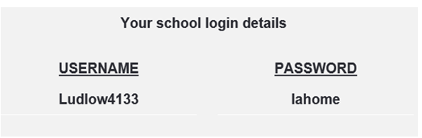

Under the Entry Level Challenge section, select Unit 3 – Basic Vocabulary. Then select lesson 2 and ‘start lesson’. This should be a lesson on the numbers 10-20. On each slide, select the speaker idea and the computer will tell you how the number should be pronounced. You can also have a go at completing the word puzzle on the site.
If you would like to recap last week’s learning, do this first before proceeding to today’s session.
PSHE – This week’s lesson is part 2 of your task about designing a fundraising event. If you would like to recap the task, have a look back at last week’s document saved in last week’s folder. Today, you should be able to complete your poster etc. for your fundraising event. I’d love to see it – send me a photo!

