Writing 05/01/2021 Cold Task
Over the next few weeks, we are going to be writing biographies in our English sessions.
Your task today is to write a biography of someone of your choosing (e.g. a sportsperson, fictional character). Don’t worry if you don’t know the facts – you can either research them or make the facts up!
Think about the information you might need to include within their biography. We have included an example for you to have a look at.
Remember, this is your Cold Task so we will look at biographies and how to write them more over the next few weeks,

What is a biography?
- Biographical writing is about someone else’s life. It is about a real person but written by someone else.
- A biography highlights the key events that have happened in their life, sometimes talking about their childhood.
- A biography can be written about someone who is dead or alive.

Y6 Information Text: Biography Example Text
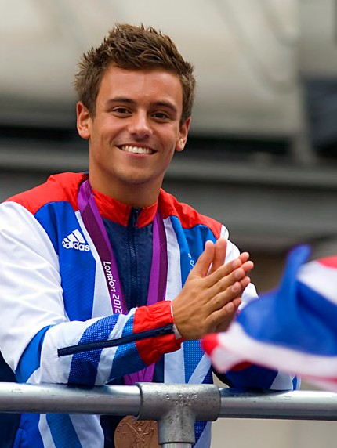
Tom Daley
Introduction
British diver Tom Daley has represented his country in many competitions worldwide, including three Olympic Games. He specialises in platform dives - both as a solo athlete and in synchronised events.
Family and Early Life
Thomas Robert Daley was born in Plymouth on 21st May 1994. His father, Rob, trained as an electrician while his mother
(Debbie) was a housewife. Tom is their eldest child: his two brothers, William and Ben, are three and five years younger than him. Tom attended local schools and, despite his education being interrupted by competitions, he still achieved great exam results at his secondary school.
Sporting Beginnings
Having learned to swim at the age of four, Tom then began diving lessons at his local pool aged seven. Although, he was also keen on other sports including judo. He was soon spotted by diving coach Andy Banks, who became his trainer when Tom was eight years old. From that age onwards, Tom was part of an increasingly intensive training regime – including regular lessons and training camps in other cities. He has admitted that he found being away from home very difficult as a young child, and when Tom was placed in a competitive squad and began travelling to diving events, his father decided he would give up his job and accompany Tom on the road; had he not been there, Tom might not have become so successful.
First Signs of a Star
Only one month after his tenth birthday, Tom became the youngest-ever winner of the under-18 platform competition in the National Junior Championships. Unfortunately, despite the fact he had met the tough qualification standard for the 2006 Commonwealth Games, Tom couldn’t be selected for the England team at that time since he wasn’t old enough. However, later in 2005 at the British Championships, he did become the under-18 champion in 10m platform and 3m springboard.
Continued Success
Progress, achievements and awards came thick and fast after that for Tom: he was junior 10m champion at the British Championships in 2005, 2006 and 2007; BBC ‘Young Sports Personality of the Year’ award winner three times and by the age of 14, he was Britain’s youngest competitor at the 2008 Beijing Olympics. There, he reached the final with his dive partner Blake Aldridge, as well as competing in the individual 10m event. At 16, he was a double-gold winner at the Commonwealth Games.
After the success of the 2012 Games, Tom returned to training and school, studying hard for his exams. He became a celebrity supporter of ChildLine, a children's helpline run by the NSPCC, and revealed that he had been bullied earlier in his schooldays. Because of this, Tom’s parents moved him to a new school; he was much happier there.
Competition success continued meanwhile, and in 2016, Tom was selected for the Rio Olympics. He was hugely disappointed not to win a medal in the individual event but that was partly forgotten when he and partner Daniel Goodfellow won bronze in the synchronised 10m dive.
Dedicated Sportsman
Even at that point, aged only 22, Tom was already regarded as a ‘veteran’ athlete, and is seen as an inspiration for young sports fans across the United Kingdom. His determination and willingness to train incredibly hard make him an excellent role model. As Tom says, “Oh, you have to want it more than anything. It has to be the biggest thing in your life – otherwise why would you do it?”

