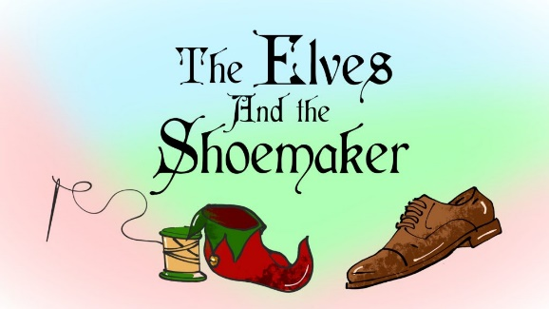
Spring Term Week 3
This week we will be continuing our topic based on Traditional and Fairy Tales. We will be focussing on ‘The Elves and the Shoemaker’.
In Literacy we will be retelling the story and will describe the boots/shoes we have designed.
In Maths we will be counting carefully, doubling and exploring shape.
In the afternoons we will be reading and will be designing our own boots and shoes.
We still have MANY missing items of uniform and PE kit. Please could you look at the labels in your child’s uniform to check they have the correct sweatshirt, PE kit etc. Thank you.
Monday | PE
Tuesday
Wednesday
Thursday | Visit The Spinney  CHAT books handed in
Friday | Reading records handed in

Dates for your diary
February 14th - Traditional/Fairy tale dress up day and sharing assembly 2:15pm
February 14th – Break up for half term

