You do not need to print anything out if it is easier not to. You can complete all the work in your workbook or on a piece of paper.
Year 6 Remote Learning Friday 26th February
9:00 – 10:15 Maths.
If you can, join in via Microsoft Teams. If not, use the following link to watch the White Rose video, before completing the work on the pdf file, saved in the folder.
This lesson we are going to be continuing our learning to solve one step equation
If you cannot join in on the live lesson, use this video link https://vimeo.com/502634894
Then, complete the questions on the document saved in the folder.
10:15 – 10:30 BREAK
10:30 – 11:15 Reading
Again, if you can, join in via Microsoft Teams. If not, work through the reading comprehension called, ‘Friday’s Reading – The Sunset Sailor’ saved in the folder.
11:15 – 12:15 Writing

We will be continuing our work on writing newspaper articles. If you can, join in via Microsoft Teams. If not, work through the PDF lesson saved in the folder on the website.
12:15 – 1:15 LUNCH
Spanish
We will be starting to learn some Spanish in school. Go to this website and type in the login details below https://www.languageangels.com/homeschool/
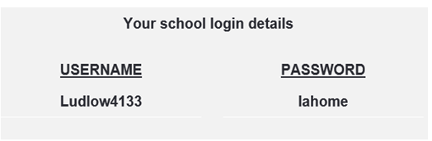

Under the Entry Level Challenge section, select Unit 3 – Basic Vocabulary. Then select lesson 4 and ‘start lesson’. This should be a lesson on colours. On each slide, select the speaker idea and the computer will tell you how the number should be pronounced. You can also have a go at completing the word puzzle on the site.
If you would like to recap last week’s learning, do this first before proceeding to today’s session.
PSHE – Work through the PDF document saved in the folder.

