ANDREW'S STORY

Central African Republic
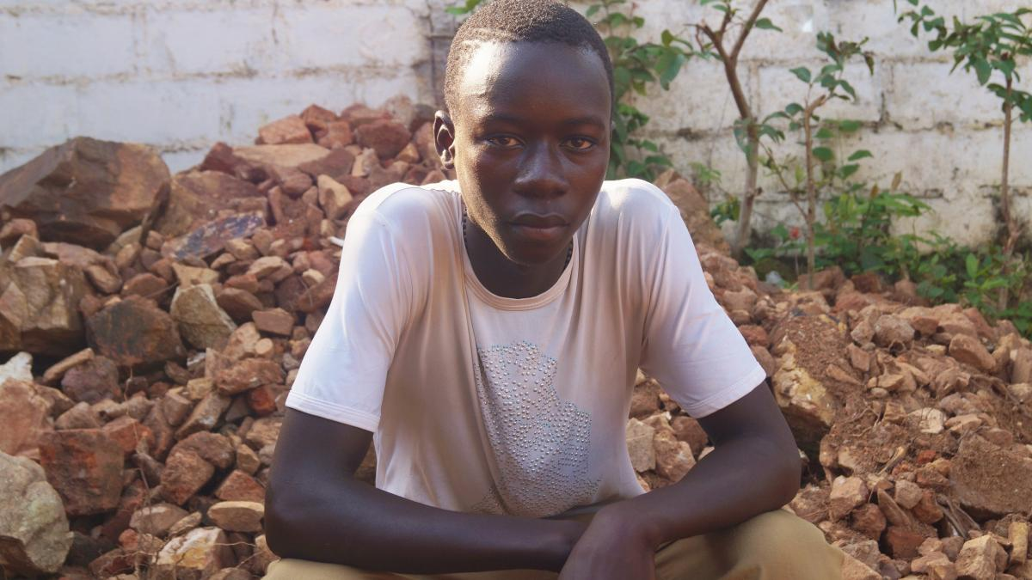Andrew's name has been changed to protect his identity

“I used to have a good life, but since the conflict started, things changed. I’ve seen people beheaded. I’ve seen people have their hands and noses cut off. I’ve seen their bodies cut into pieces. My parents were killed. Some other family and friends too. There are lots of things that I miss.”

TEENAGER IN WAR
Andrew lives the Central African Republic which is one of the most neglected crises in the world. He is 15-years-old. At his age he should be concentrating on school and playing with his friends. But the crisis in his country means he cannot do any of those things.

GUNSHOTS AT SCHOOL
“I’m unable to go to school mainly because there are lots of gunshots. I get really scared when I hear the gunshots. In a nearby district, there was a confrontation between [militias] and UN forces right outside the school. There were a lot of pupils nearby on their way to an exam and they were told to turn back because of gunshots. I get really scared when I hear the gunshots.”
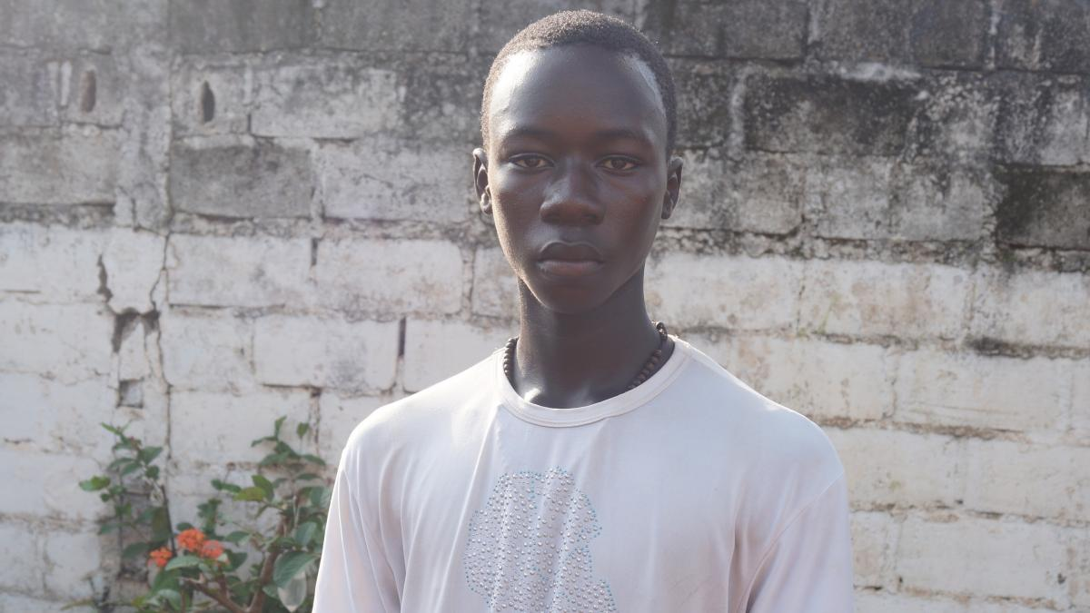Andrew should be at school instead of dodging gunfire

“What really hurts me is the conflict. I wish for there to be peace here and that people can continue with their daily lives. Prior to the conflict I was able to walk in the street and come back anytime I liked. But since the conflict erupted I have to come home early. Lots of people are suffering.”

Andrew had been training to be a carpenter. His training was interrupted when the fighting escalated in his home town. He wants to finish. But right now, what dominates his thoughts are the people he has lost and the horror he has witnessed.

“I think about what’s happened to me and what I’ve seen; it is the first time I have witnessed such things.”

SAFETY AND EDUCATION IN WAR
“This crisis resulted in us losing out on lots of things. This has put the country in a situation that we did not want.”
Andrew is faced with daily dangers. His priority is to learn and be safe. He has a simple wish for the future.
“I would like there to be peace in my country.”

Help support children like Andrew

