- Match the idiom with the correct meaning.
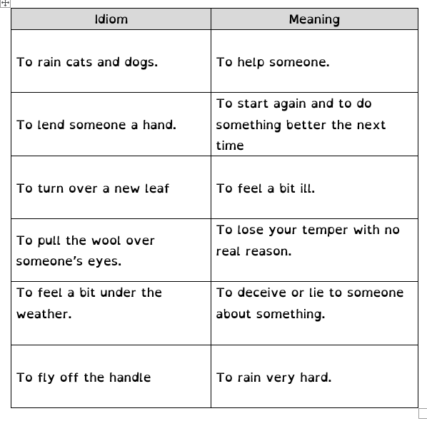
- Once you have done that, write a sentence to show the meaning of the idiom. For example, “You can’t leave just now! It’s raining cats and dogs and you don’t have an umbrella or raincoat!”

