WALT draw on reading and research to help plan our ideas
In your books, answer these questions.
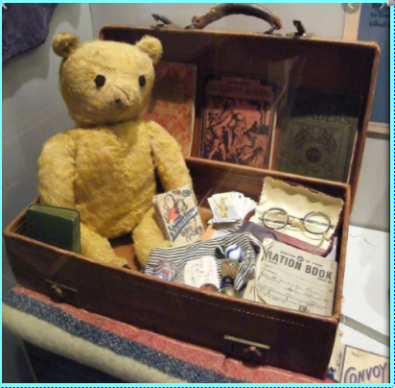
- How old do you think the suitcase is?
- Who do you think the suitcase belongs to?
- What do you think it is to be used for?
- What do the contents tell us about the owner of the case
- What else might the owner want to pack in the case?

WALT draw on reading and research to help plan our ideas
In your books, answer these questions.
- How old do you think the suitcase is?
- Who do you think the suitcase belongs to?
- What do you think it is to be used for?
- What do the contents tell us about the owner of the case?
- What else might the owner want to pack in the case?

