You do not need to print anything out if it is easier not to. You can complete all the work in your workbook or on a piece of paper.
Year 6 Remote Learning Friday 22nd January
9:00 – 10:15 Maths.
If you can, join in via Microsoft Teams. If not, use the following link to watch the White Rose video, before completing the work on the pdf file, saved in the folder.
This lesson we are going to be continuing our learning on how to multiply decimals by integers (whole numbers)
If you would like to recap yesterday’s lesson, follow this link to watch the video - https://vimeo.com/490690764
Then, complete the questions on the document saved in the folder.
10:15 – 10:30 BREAK
10:30 – 11:15 Reading
Again, if you can, join in via Microsoft Teams. If not, work through the reading comprehension called, ‘First Aid’ saved in the folder.
11:15 – 12:15 Writing

In school, we will be finishing off writing our biographies (see the video link from yesterday).

If you have done this, complete the ‘Extra Writing Task 3’ saved on the school website. Think carefully about the descriptive nature of this task and the impact that you want your writing to have upon the reader.
12:15 – 1:15 LUNCH
Spanish
We will be starting to learn some Spanish in school. Go to this website and type in the login details below https://www.languageangels.com/homeschool/
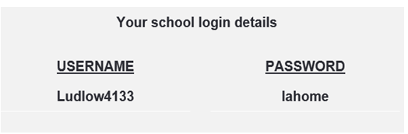

Under the Entry Level Challenge section, select Unit 3 – Basic Vocabulary. Then select lesson 1 and ‘start lesson’. This should be a lesson on the numbers 1-10. On each slide, select the speaker idea and the computer will tell you how the number should be pronounced.
PSHE – read through the information on the document saved on the website.
This task is designed to last for two sessions so take your time and do a careful, thorough job.

