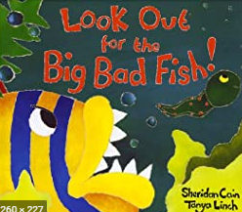
Spring Term Week 11
This week we would have been looking at the season of spring. We would have gone on a spring walk, looking for blossom, buds and spring flowers.
In Literacy we would be retelling the story of ‘Look Out for the Big Bad Fish’ and writing about the life cycle of a frog.
In Maths we would have been working on shape, making pictures in the style of Paul Klee. We will be looking at subtraction and we be singing along with Number Blocks to look at number bonds to ten.
In the afternoons we would be reading and ordering the life cycle of a frog. We’d walk up to The Spinney and look at how frogs are developing in our school pond.
We would have made Easter cards by making handprint tulips, cutting them out and adding to a card.
Please keep fit by watching Joe Wicks PE session at 9am each day.

