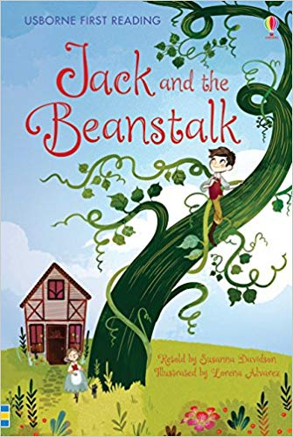
Spring Term Week 6
For our final week on our Traditional Tales topic, we will be reading ‘Jack and The Beanstalk’.
In Literacy we will be labelling pictures from the story.
In Maths we will be doubling hearts.
In the afternoons we will be planting magic beans and rehearsing for our sharing assembly.
The sharing assembly will be finished at approx. 2.45pm. We will then take the children back to their classroom to collect their belongings. You will then be able to take your children home straight after this.
Please can you check your child’s uniform. We have several missing pieces, including jumpers, polo shirts and a pair of boy’s trousers. Please ensure your child’s uniform is clearly labelled.
Dates for your diary
February 14th - Traditional/Fairy tale dress up day and sharing assembly 2:15pm
Monday | Mrs Barrow’s class – The Spinney  Miss Jewell’s class – PE
Tuesday
Wednesday | Science afternoon
Thursday | CHAT books handed in
Friday | Reading records handed in  Dress up day/Sharing Assembly 2.15pm
February 14th – Break up for half term
February 24th – Back to school

