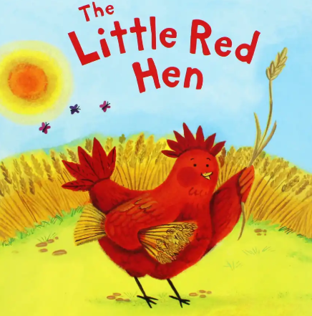
Spring Term Week 7
This week we begin our new theme, New Life.
In Literacy we will be retelling the story of The Little Red Hen and we will be writing instructions for making bread.
In Maths we will be working on addition, sharing and counting carefully.
There will be a change to our timetable, on Monday. There will be no PE or visit to The Spinney as we will be baking bread.
In Science we will be exploring what is inside an egg?
Half Term Homework
Can you test egg shells to find out how strong they are? You should ask an adult to help you carefully crack two hen’s eggs so that two complete domes are left. How hard were they to break? Is it good that eggs break easily? Can you balance a book on the two half egg shells? How many books can they hold? Why is it important for the eggs to be strong? We will share your findings on Thursday 27th February
Monday | Baking bread
Tuesday | Science afternoon
Wednesday
Thursday | CHAT books handed in
Friday | Reading records handed in

Dates for your diary
February 24th – Back to school

